**NAAN MUDHALVAN DIGITAL MARKETING ASSIGNMENT**

AU913120104099– Suresh A

# LINKEDIN CREATION:

Visit LinkedIn: Go to LinkedIn's website at [www.linkedin.com.](http://www.linkedin.com/)

Sign Up: On the LinkedIn homepage, you'll see a "Join now" or "Sign up" option. Click on it.

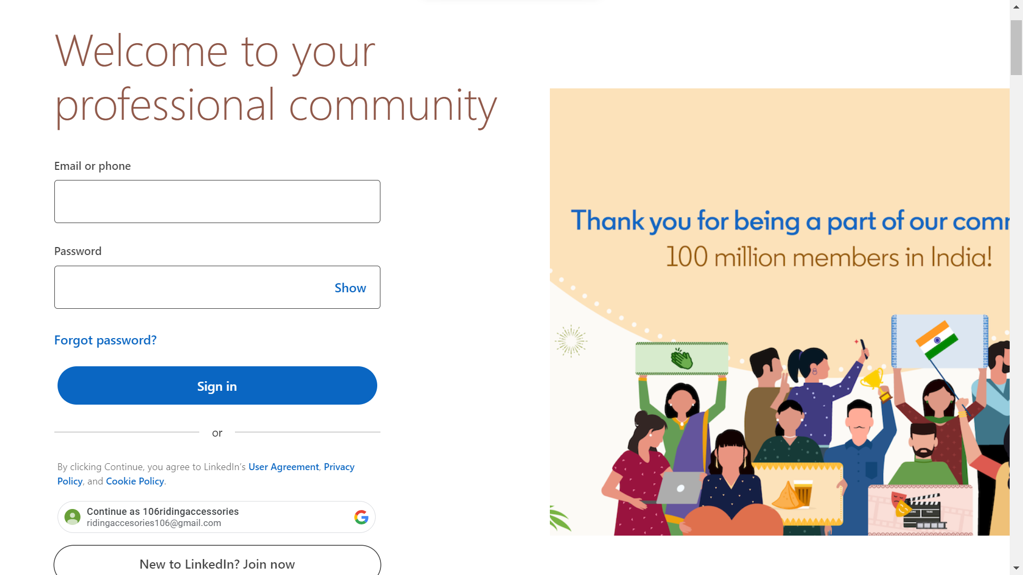

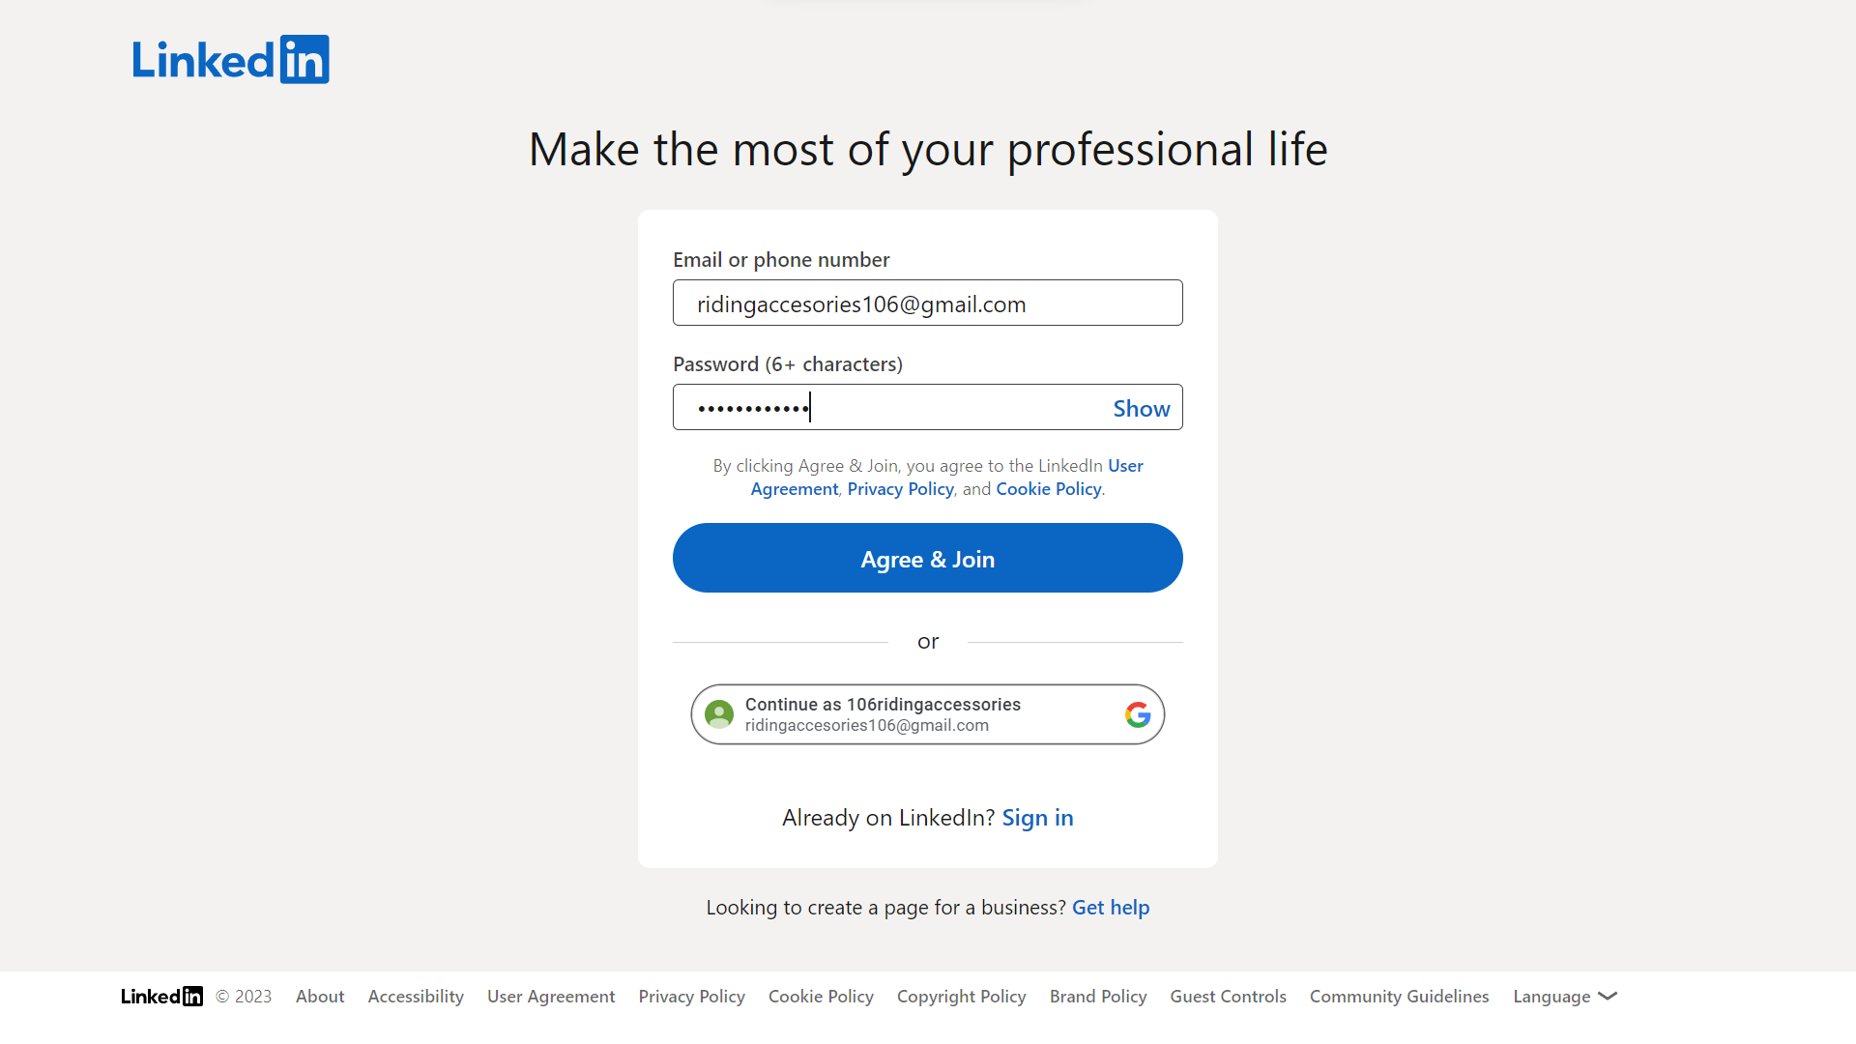

Provide information and complete profile

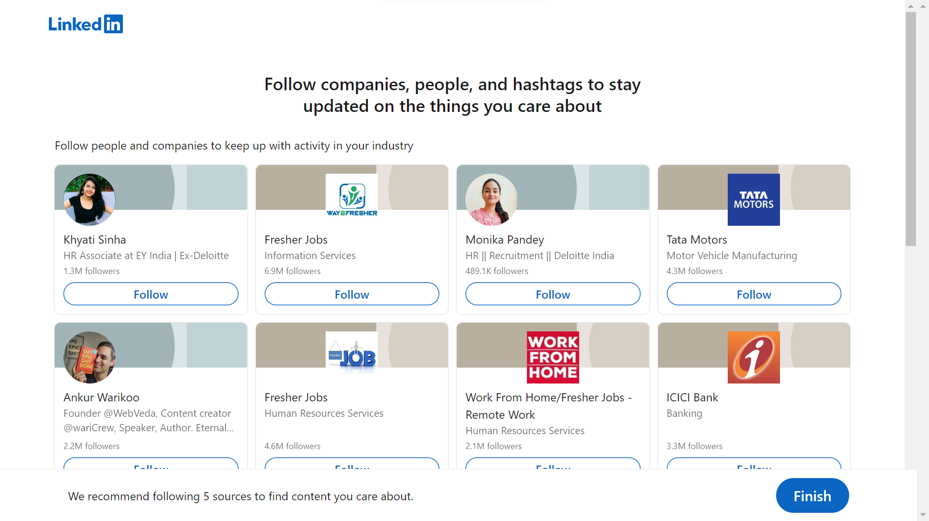

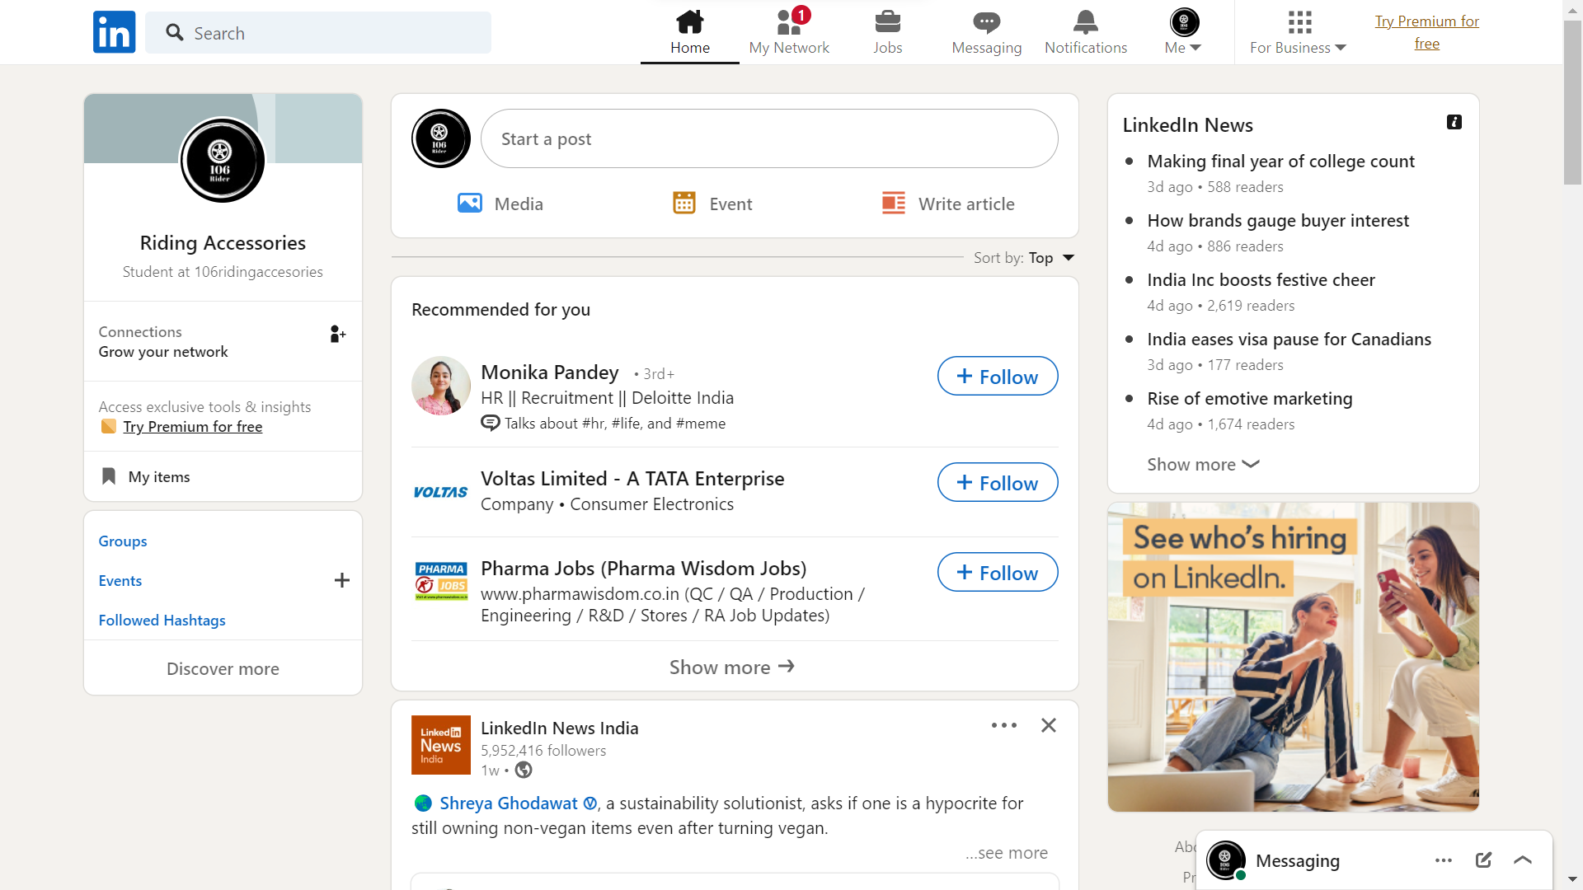

## BRAND NAME: 106 RIDING ACCESSORIES

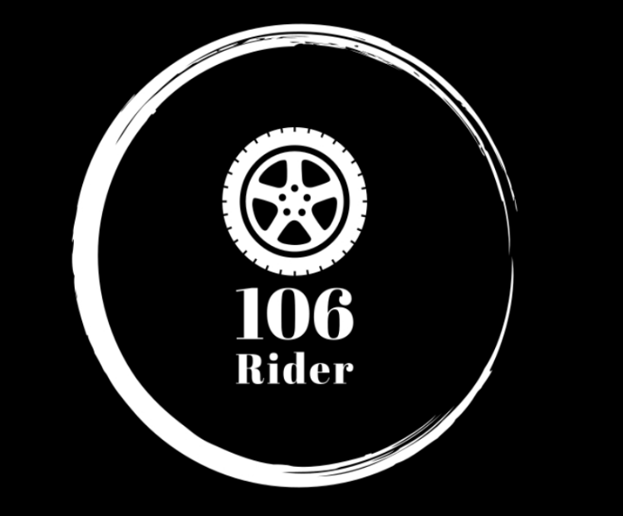

* **CREATION OF BLOG PAGE:**

**Blog Url:** <https://106ridingaccesorie.blogspot.com/>

Creation of a blog page starts with providing details and the page is created, then selecting the Layout for a good look on the user side.

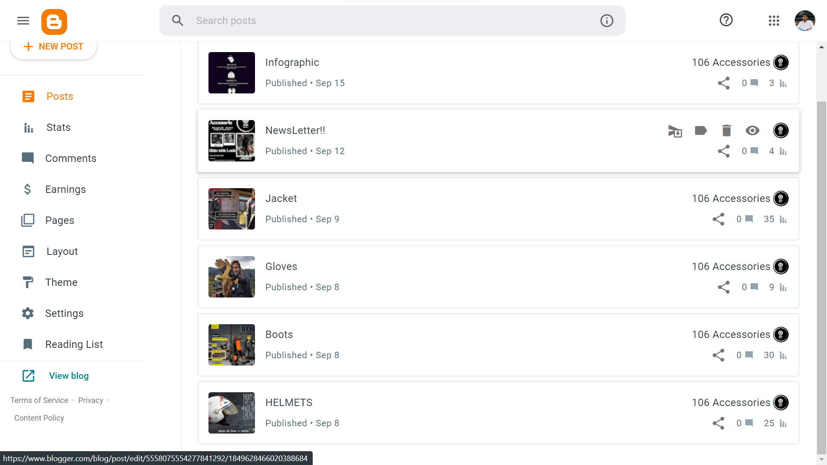

Then provide the details required for the profile on the page

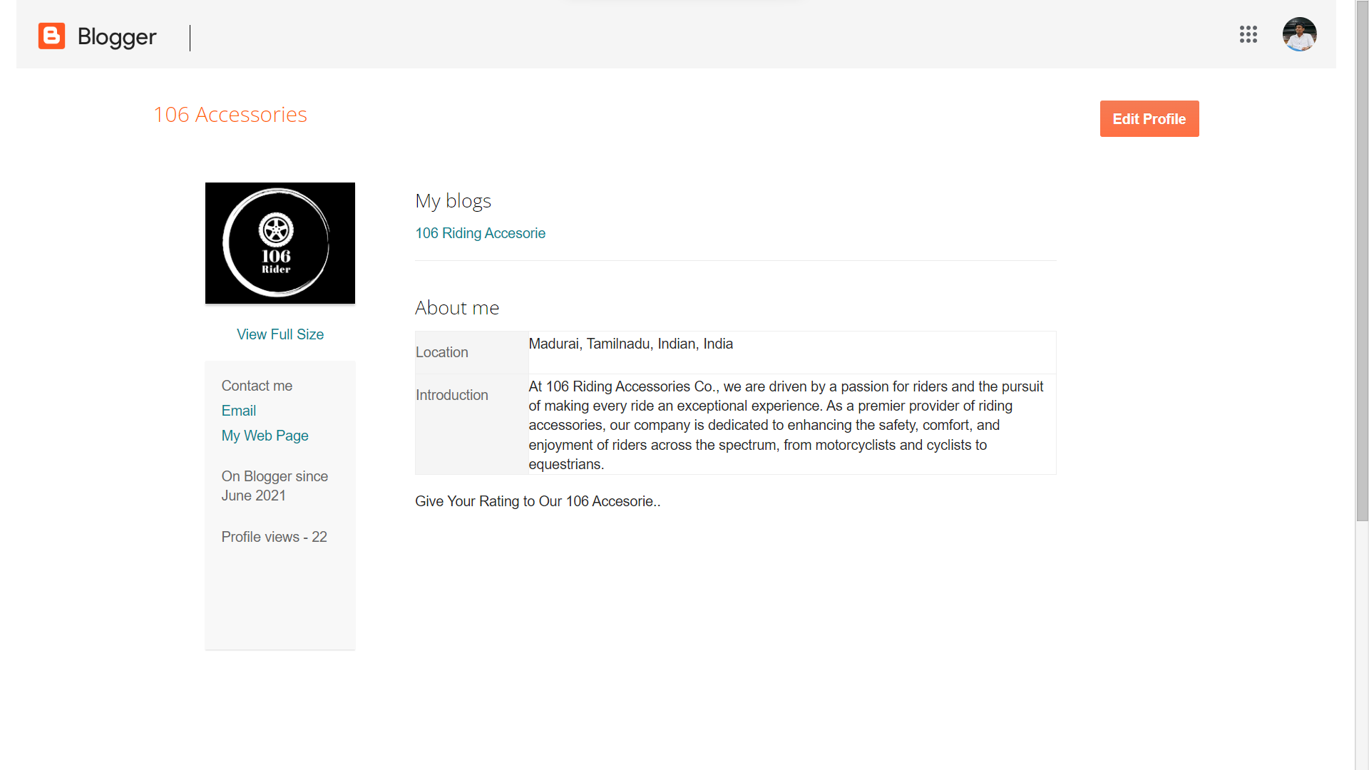

Then the blog home page is created for 106 Riding Accessories.

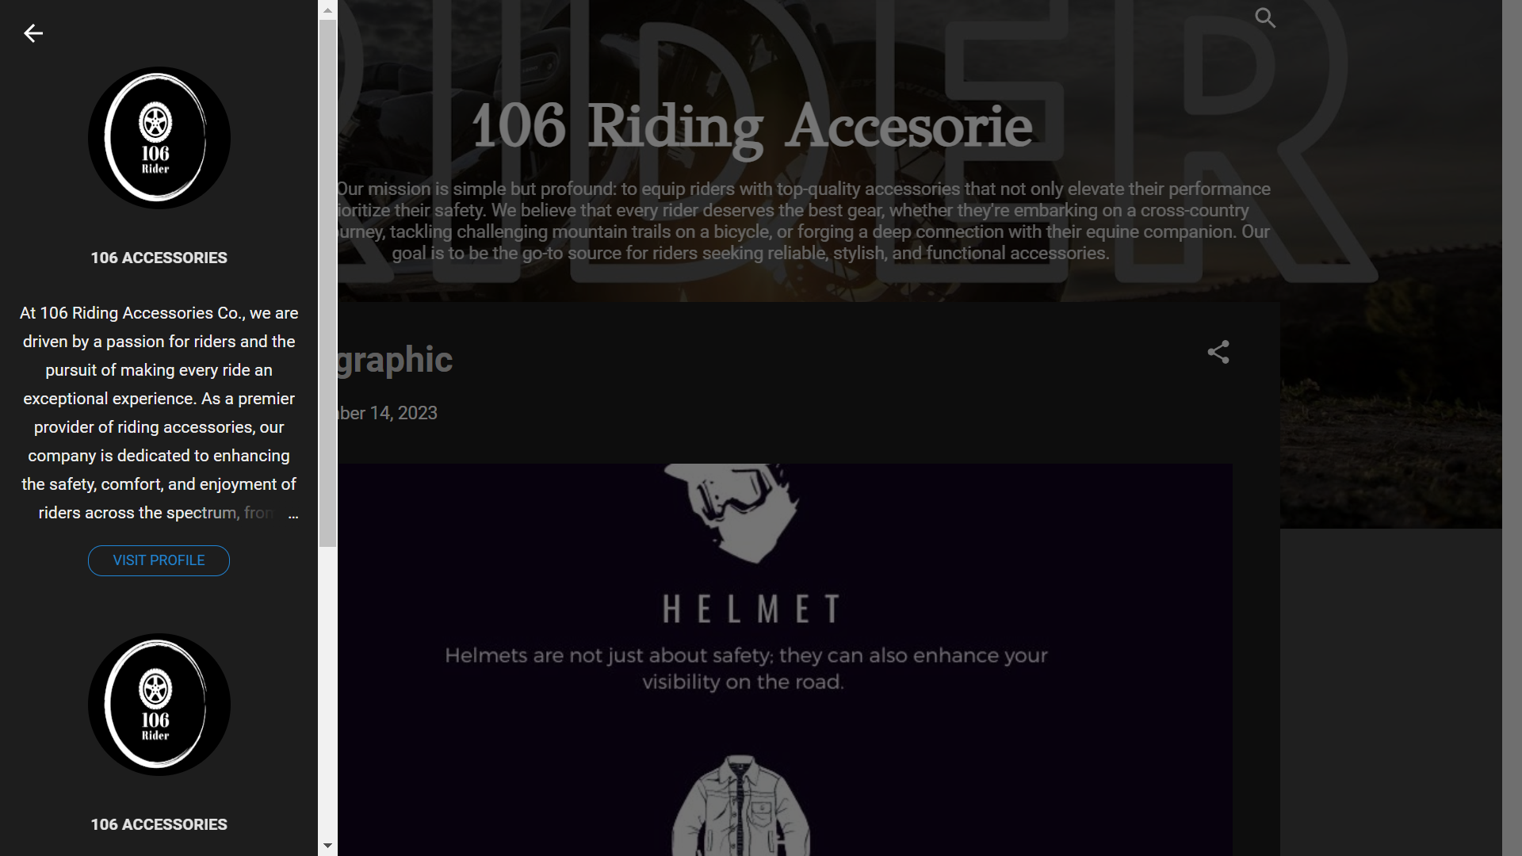

Then add posts that explain the services and the details of the accessories that are provided on the blog such that it reaches the client effectively.

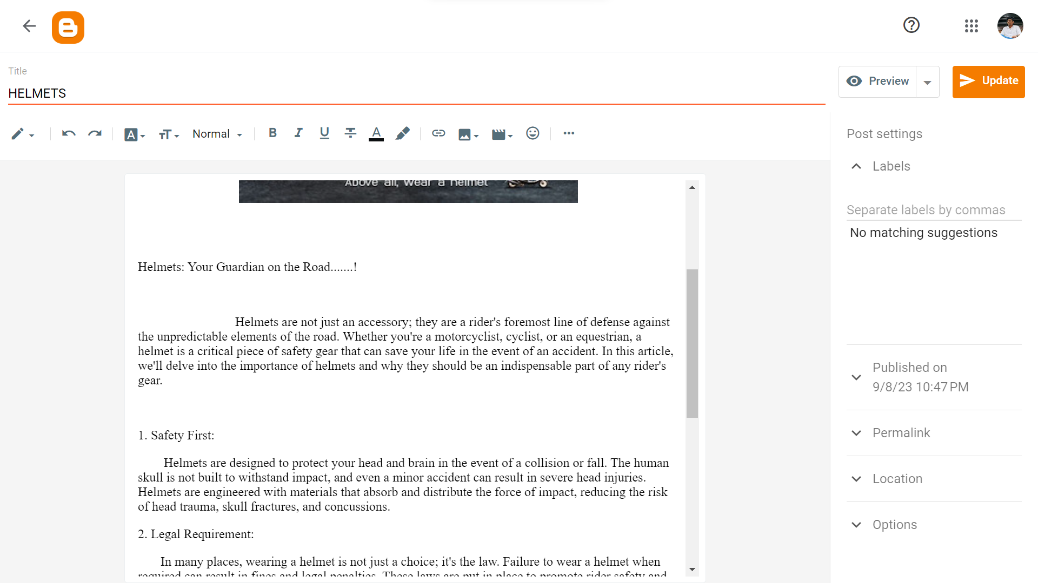

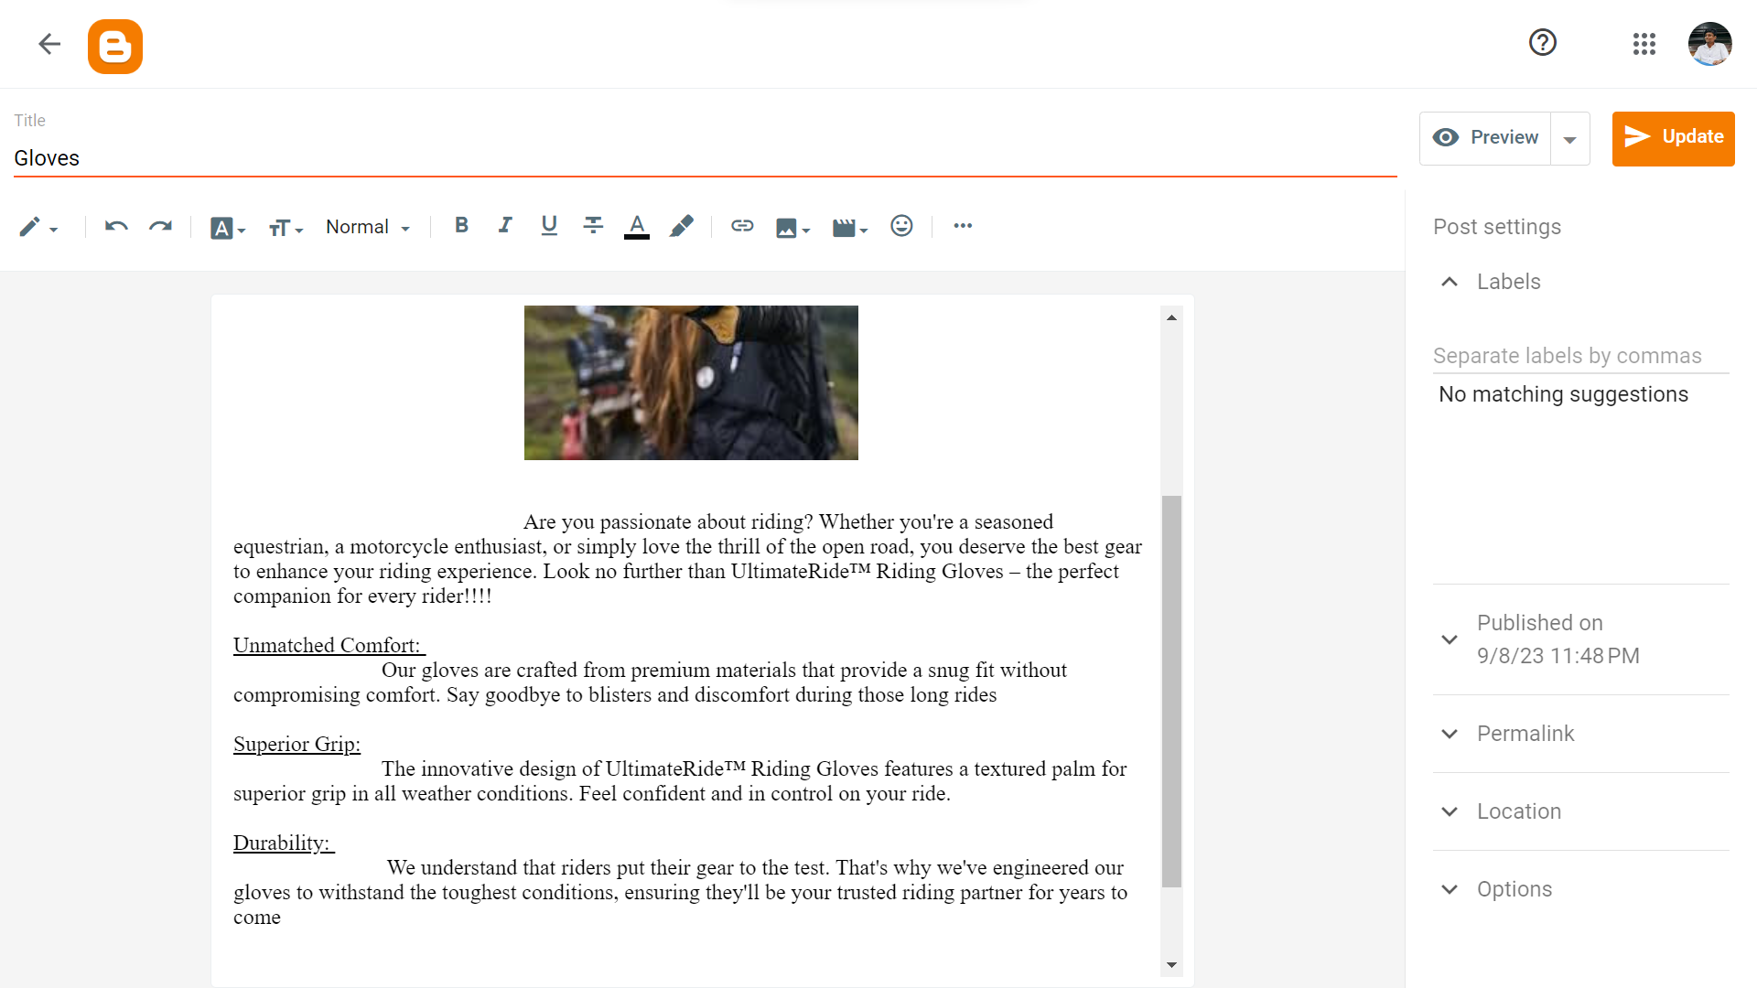

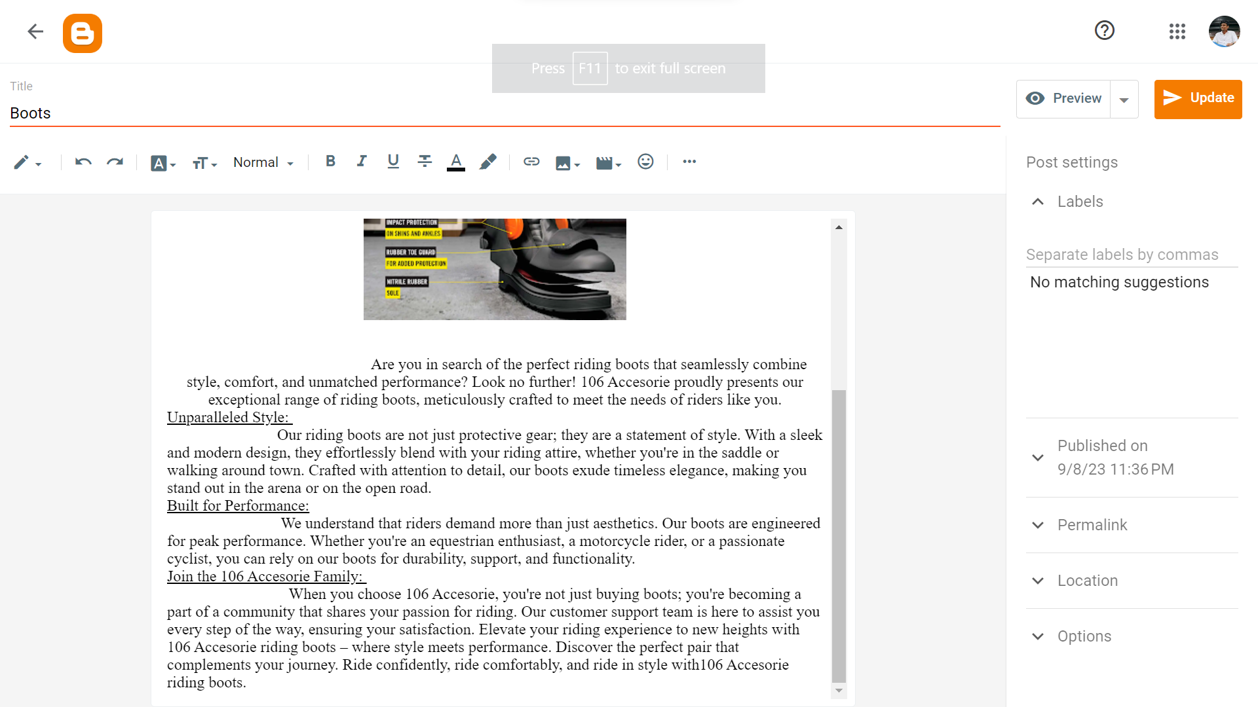

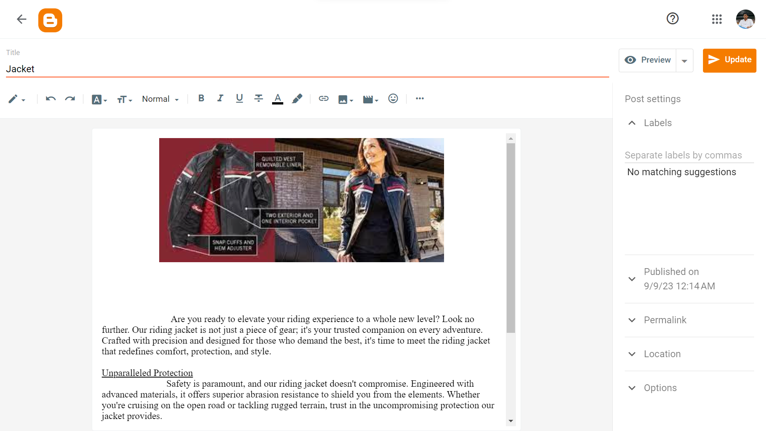

After completing the post save it and publish.

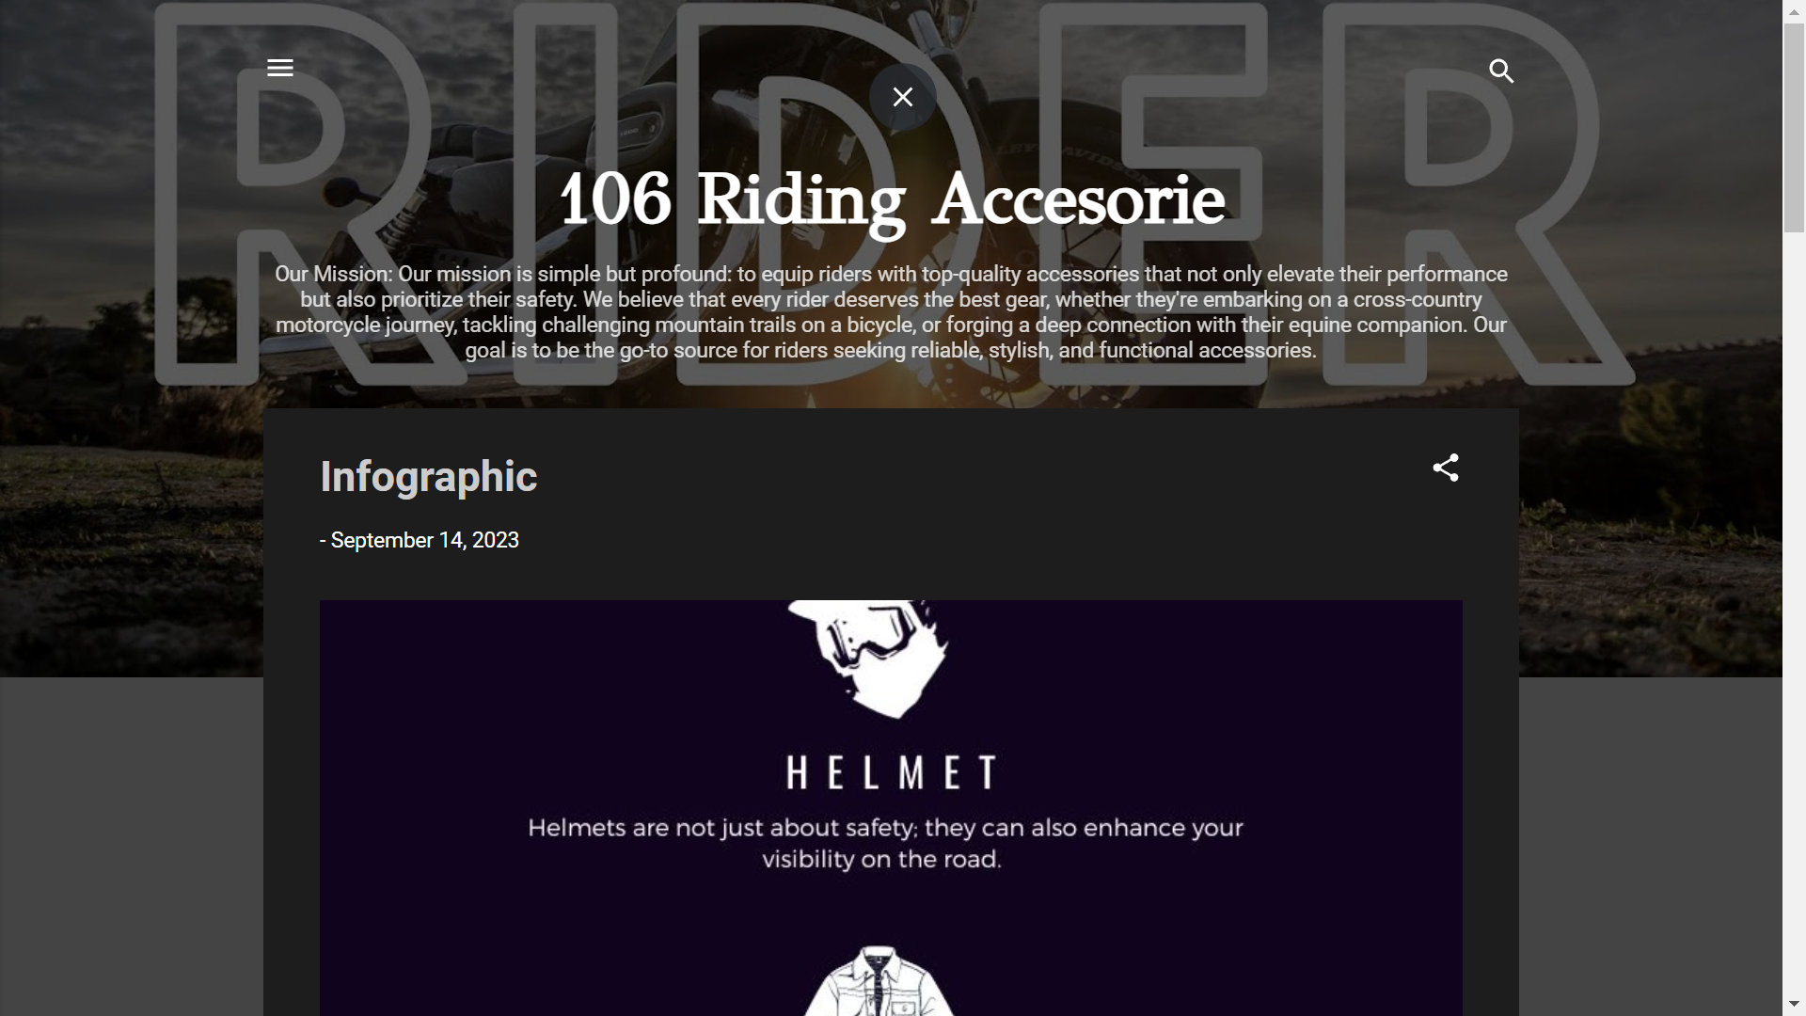

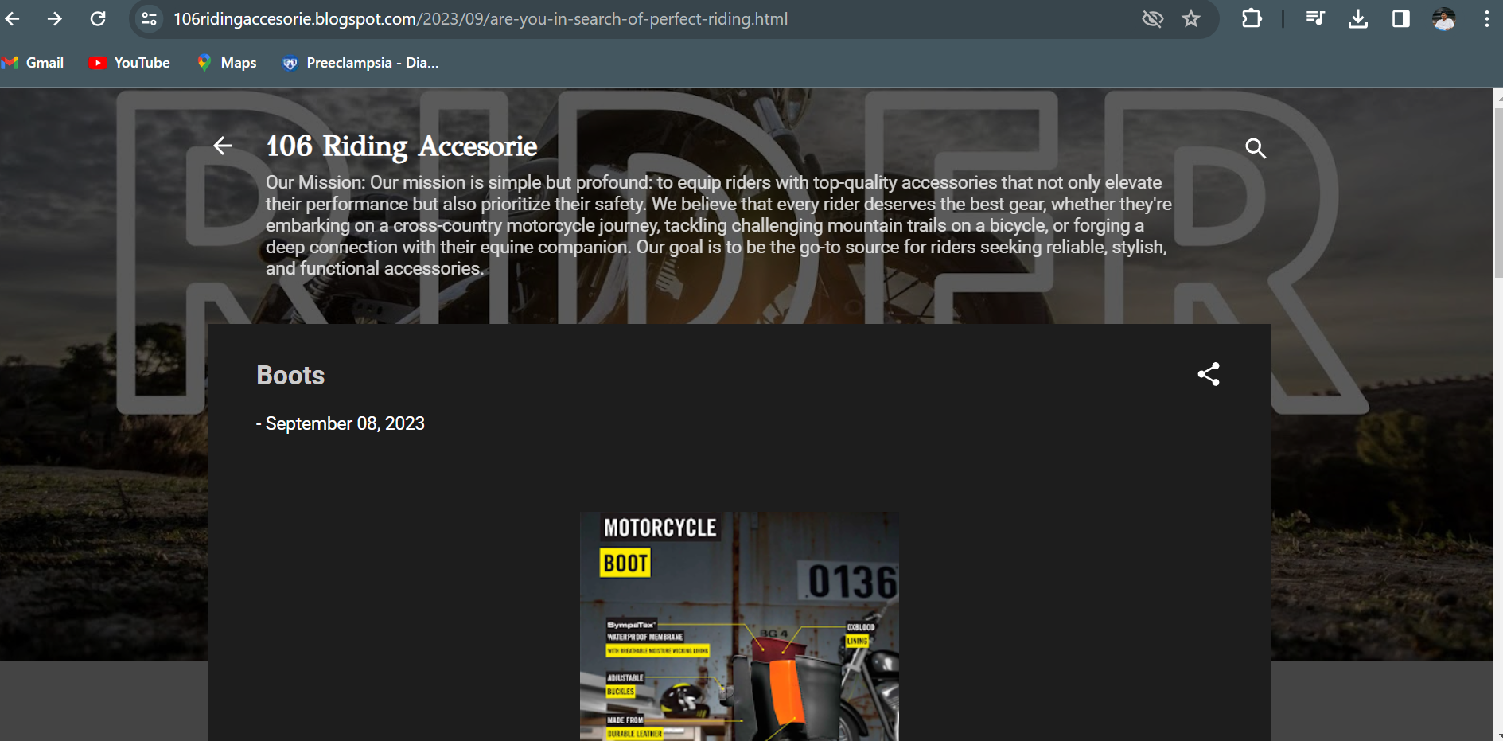

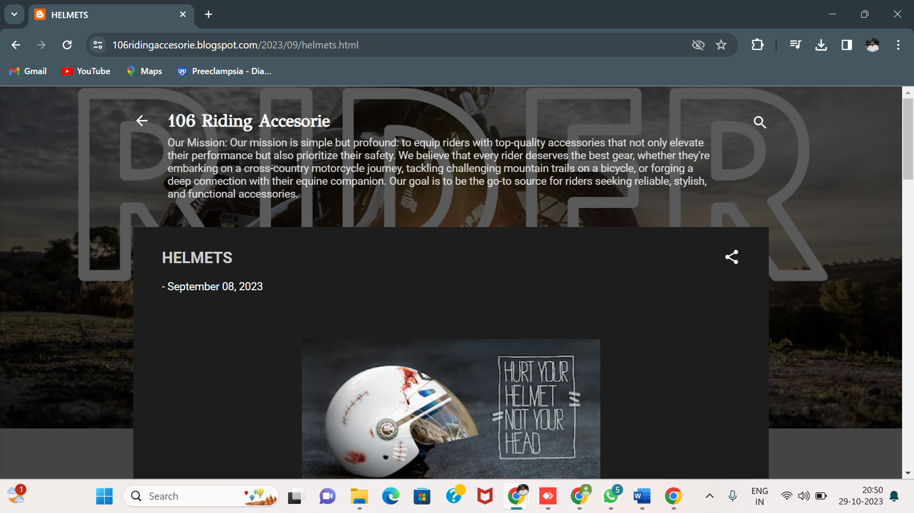

## FACEBOOK PAGE:

**Facebook page Url:** <https://www.facebook.com/profile.php?id=61550477902410>

Facebook business page for 106 Riding Accessories is a page that has all the accessories that are related to riding.

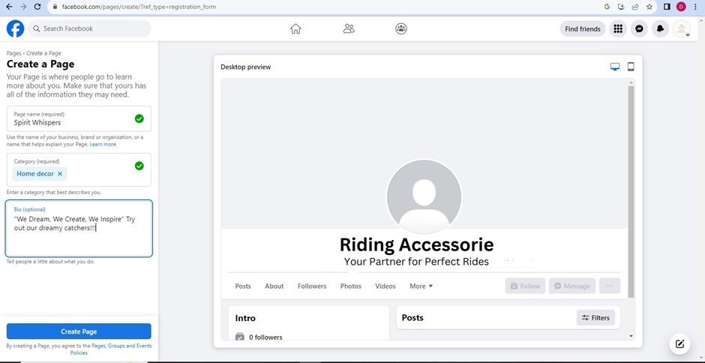

Then we customize the page by providing a profile and banner to attract and increase visitors to the page which is an essential factor to the business.

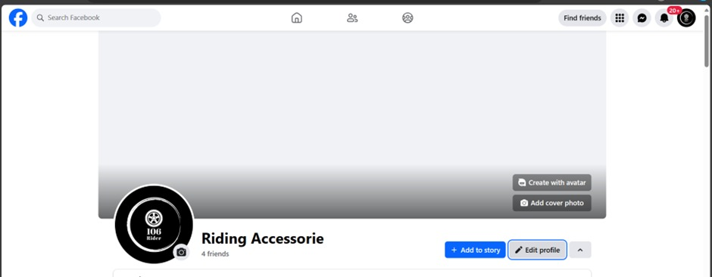

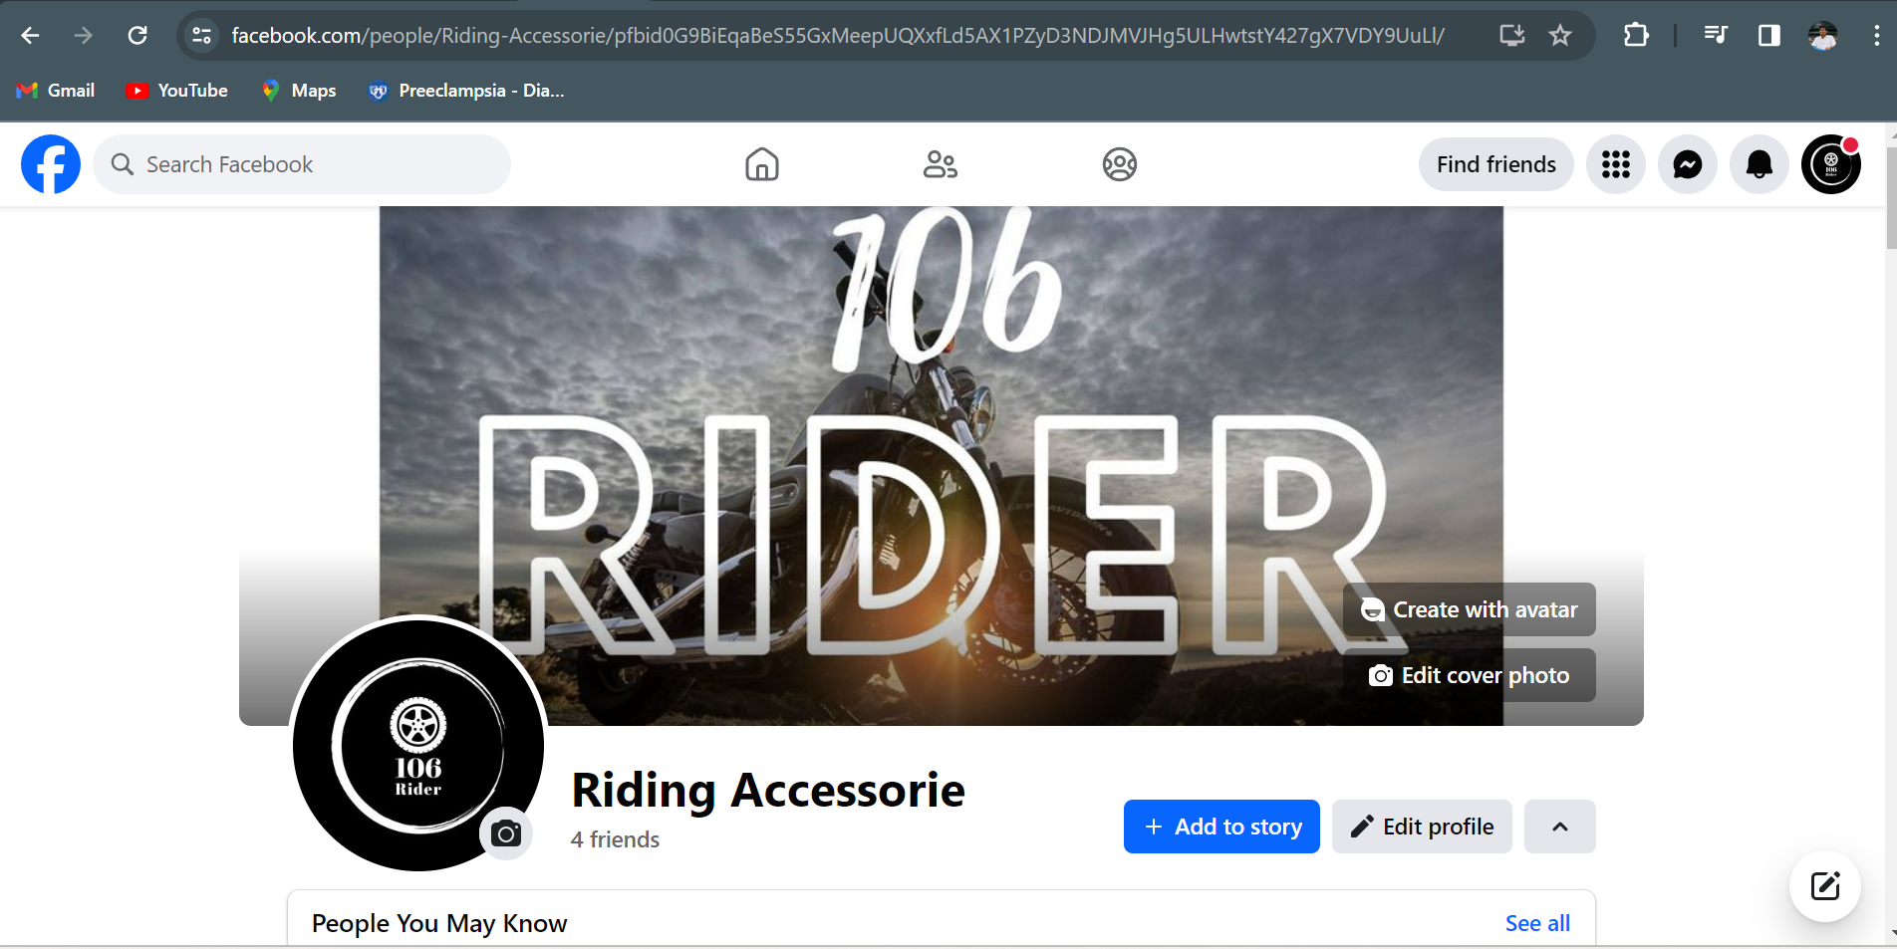

This is the Facebook page of 106 Riding Accessories

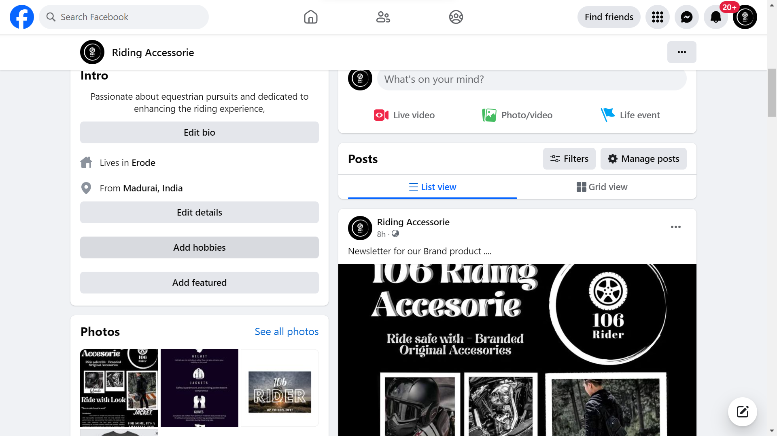

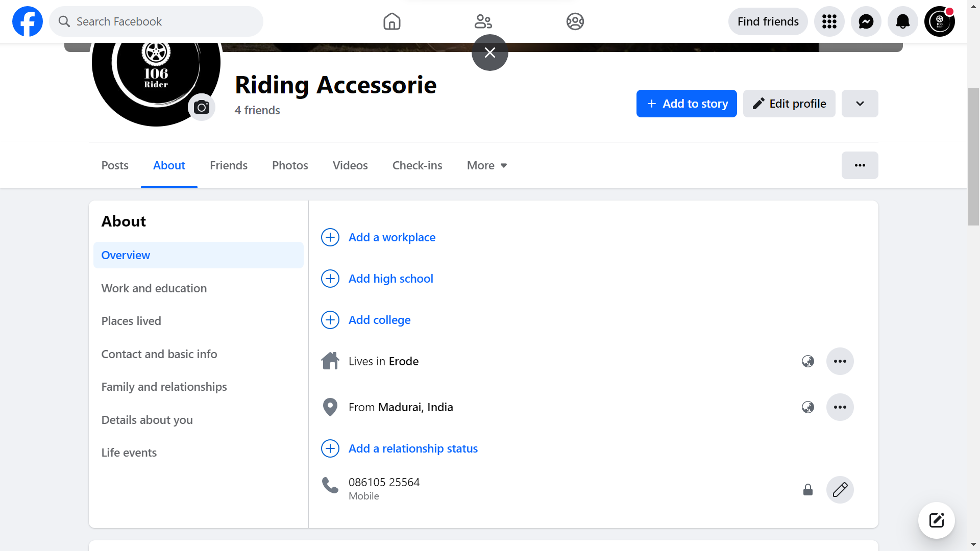

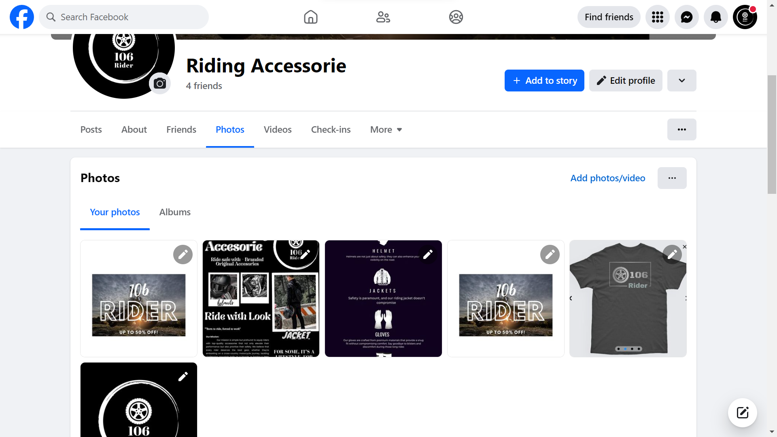

# EMAIL NEWSLETTER POST:

**Email Newsletter Post – Blog Url:**

[**https://106ridingaccesorie.blogspot.com/2023/09/newsletter.html**](https://106ridingaccesorie.blogspot.com/2023/09/newsletter.html)

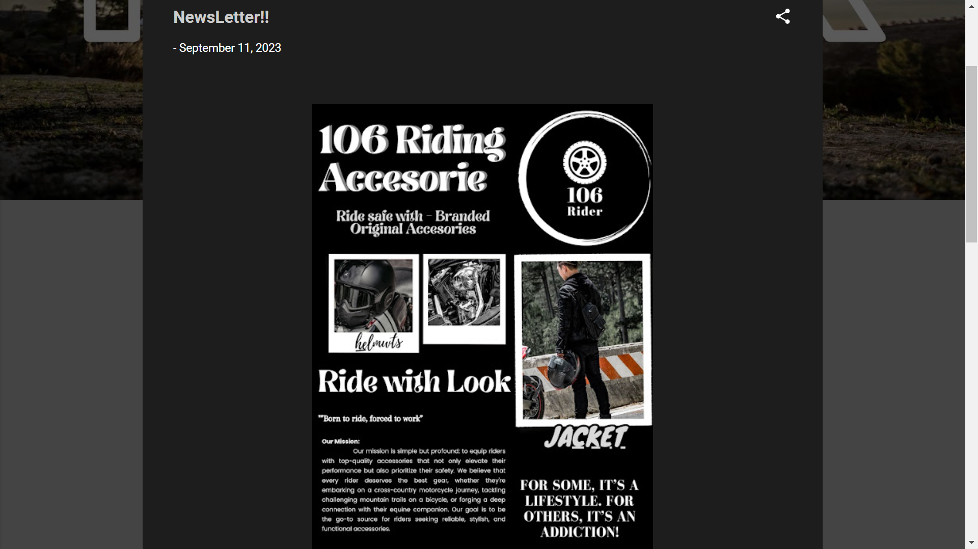

## INFOGRAPHIC POSTER:

**Infographic Post – Blog Url:**

**https://106ridingaccesorie.blogspot.com/2023/09/infographic.html**

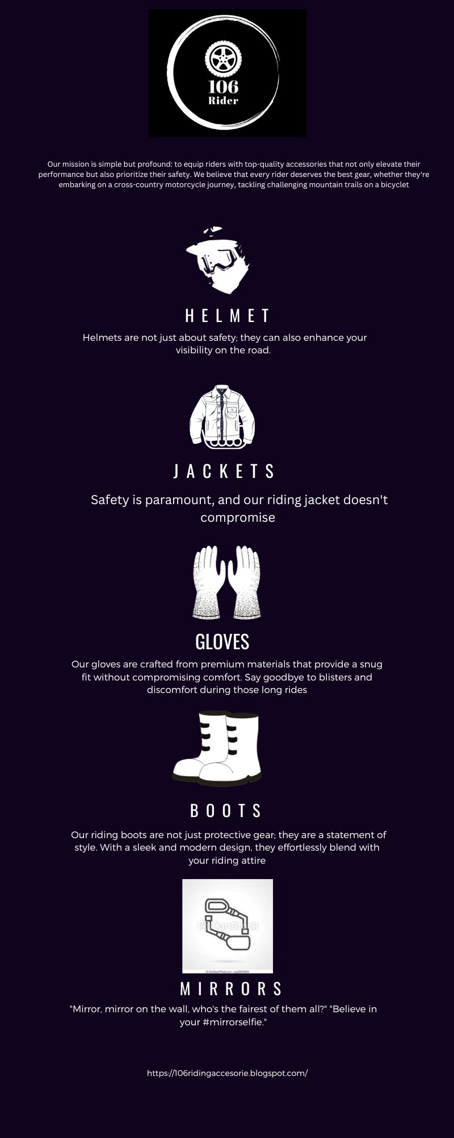

## GOOGLE ANALYTIC MEASUREMENT ID:

**Google analytic measurement ID:**

G-ZG8D1NYSJS

Visit Google Analytic official page

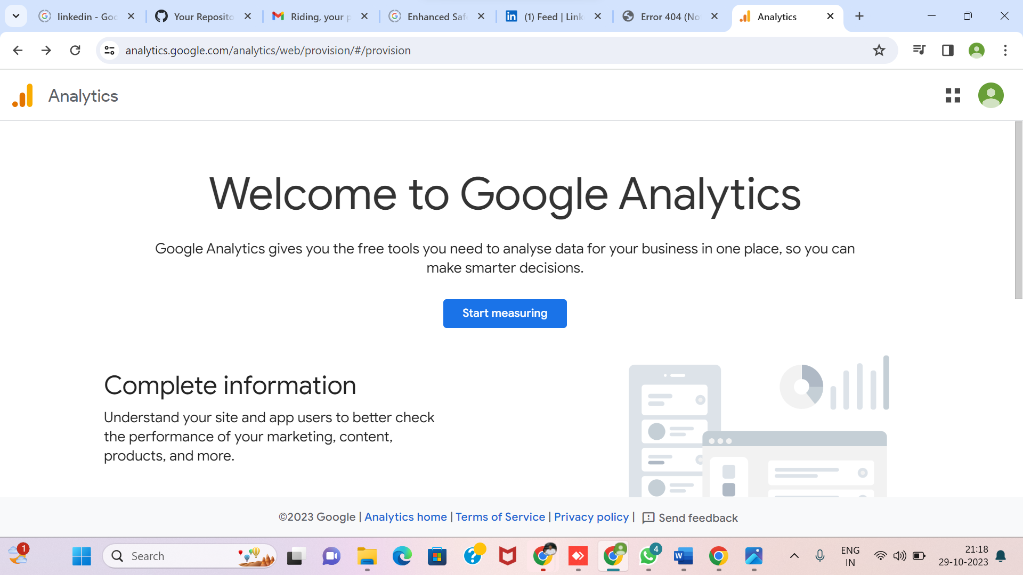

Create an account by means of enter details

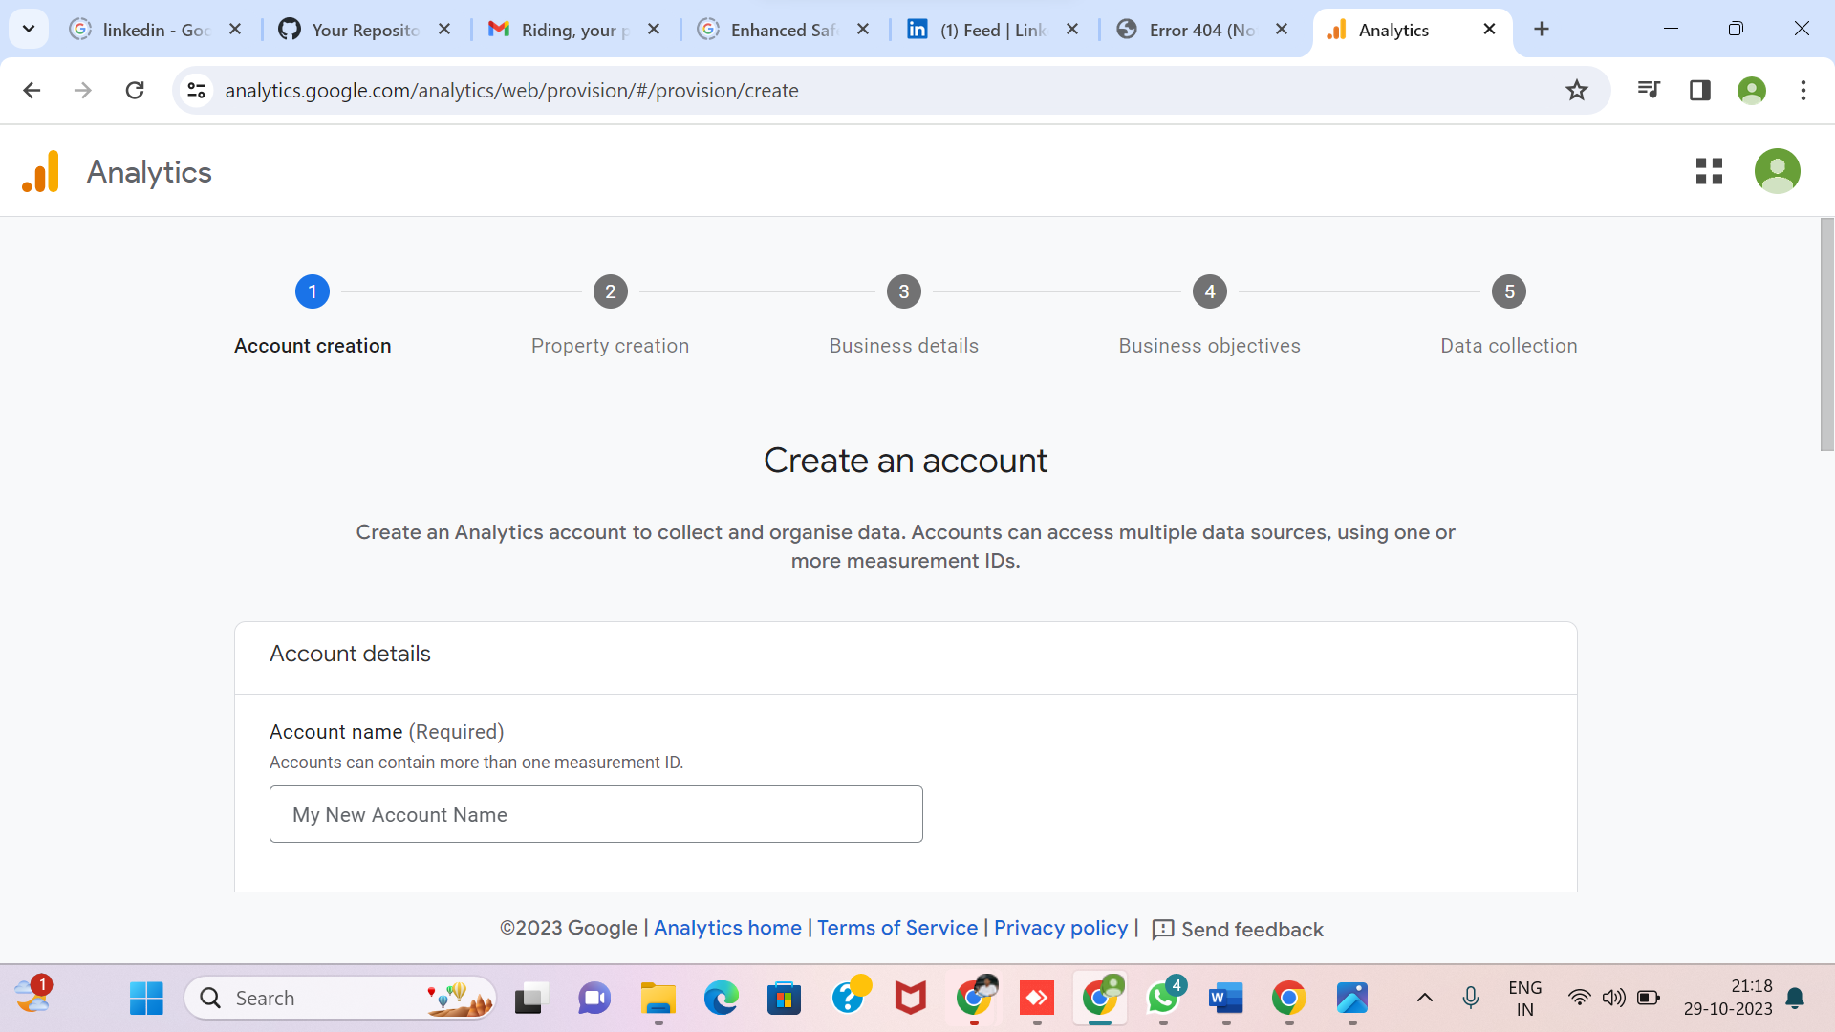

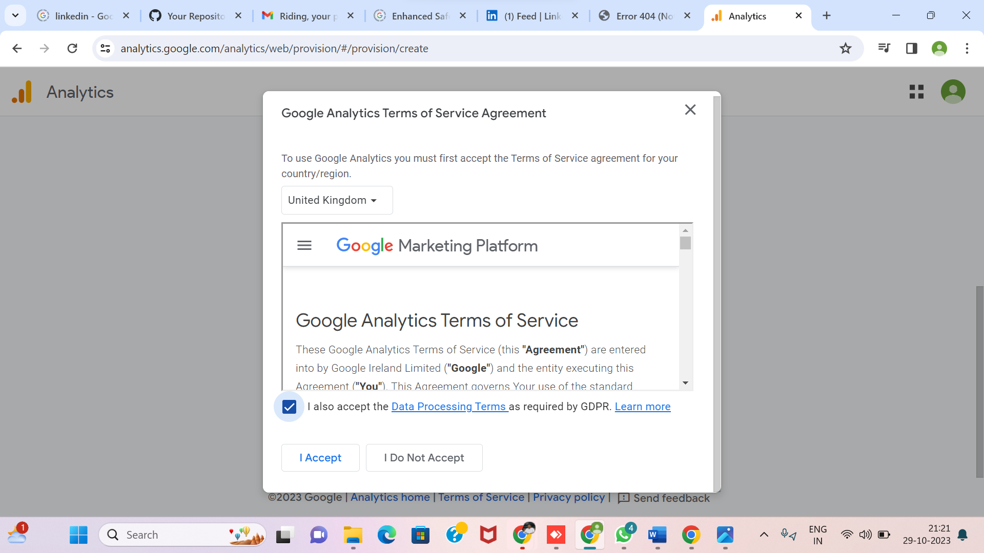

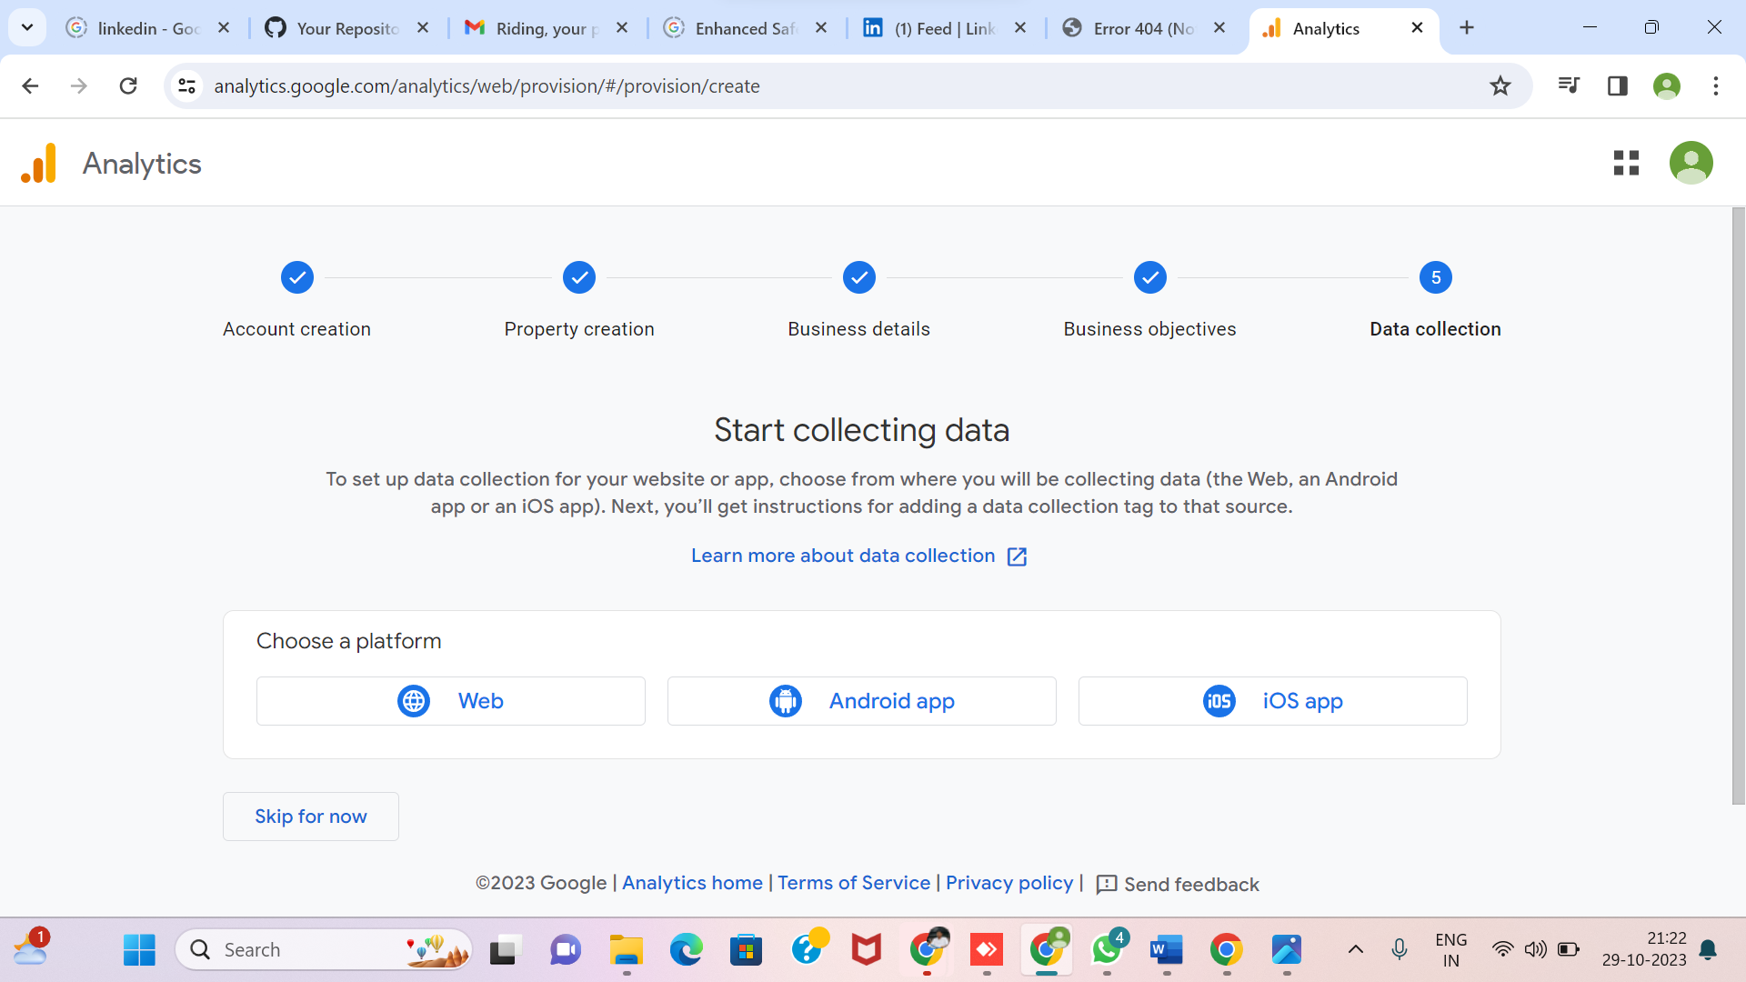

Then click Web to create a Stream

